**Chapter 27: The Electric Field**

Table of Contents

27.4 Calculation of $E$ 2

27.5 A Point Charge in an Electric Field 6

## 27.4 Calculation of $E$

$$F=\frac{1}{4πϵ_{0}}\frac{qq_{0}}{r^{2}}$$

$$E=\frac{1}{4πϵ_{0}}\frac{q}{r^{2}}$$

For a continuous range of charges, the charge at a specific range can be calculated, and the integral be used to find the total resultant electric field.

$ds$: selected distance

$dq$: charge present in the distance

$q$: total charge present

$s$: total distance

$$dq=q\frac{ds}{s}$$

Example 5:

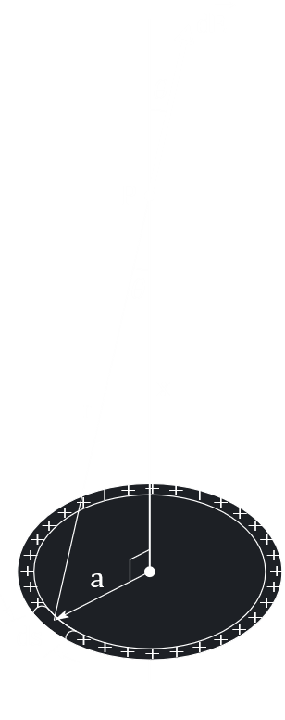

For a ring of charge $q$, radius $a$, at a distance $x$ from the center,

$$\vec{E}=∫d\vec{E}$$

where $d\vec{E}$ is the electric field due to a length $ds$ of the ring, that has a charge $dq$.

Along the axis,

$$d\vec{E}=dE\cos{θ}$$

$$∴E=∫dE\cos{θ}$$

$$dE=\frac{1}{4πϵ_{0}}×\frac{dq}{a^{2}+x^{2}}$$

$$dq=q⋅\frac{ds}{2πa}$$

$$∴dE=\frac{1}{4πϵ_{0}}×1×\frac{ds}{2πa}×\frac{1}{a^{2}x^{2}}$$

$$\cos{θ}=\frac{x}{\sqrt{a^{2}+x^{2}}}$$

$$∴E=∫(\frac{1}{4πϵ_{0}}×q×\frac{ds}{2πa}×\frac{1}{a^{2}+x^{2}}×\frac{x}{\sqrt{a^{2}+x^{2}}}$$

$$=\frac{1}{4πϵ_{0}}×\frac{q}{2πa}×\frac{1}{{\left(a^{2}+x^{2}\right)}^{\frac{3}{2}}}×∫ds$$

$$∫ds=2πa$$

And for $x≫a$, $a$ can be disregarded.

$$∴E=\frac{1}{4πϵ_{0}}×\frac{q}{2πa}×\frac{x}{{\left(a^{2}+x^{2}\right)}^{\frac{3}{2}}}×2πa$$

$$≈\frac{1}{4πϵ_{0}}×\frac{qx}{x^{3}}$$

$$∴E≈\frac{1}{4πϵ_{0}}×\frac{q}{x^{2}}$$

Example 6:



For an infinite line of change density $λ$, at a distance $y$ above the line,

$$dq=λdx$$

where $dx$ is a part of the line.

$$∴dE=\frac{1}{4πϵ_{0}}×\frac{dq}{r^{2}}$$

$$=\frac{1}{4πϵ_{0}}×\frac{λdx}{y^{2}+x^{2}}$$

$$E=\int_{x=-∞}^{x=∞}{dE\cos{θ}}=\int_{x=-∞}^{x=∞}{\frac{1}{4πϵ_{0}}×\frac{λdx}{y^{2}+x^{2}}×\cos{θ}}$$

$$x=y\tan{θ}$$

$$dx=y\sec^{2}{θ}dθ$$

$$∴E=2\int_{θ=0}^{θ=\frac{π}{2}}{\frac{1}{4πϵ_{0}}×\frac{λ}{y^{2}\left(1+\tan^{2}{θ}\right)}×\cos{θ}×y\sec^{2}{θ}dθ}$$

$$=\frac{λ}{2πϵ_{0}y}\int_{0}^{\frac{π}{2}}{\cos{θ}dθ}$$

$$∴E=\frac{λ}{2πϵ_{0}y}$$

## 27.5 A Point Charge in an Electric Field

Note that equations for charges can be used with other equations as well.

E.g. acceleration due to electric field, $a=\frac{F}{m}$

Over a distance of $y$, $v^{2}=2ay$

$$v^{2}=2\frac{Eq}{m}y$$

Kinetic energy, $K=\frac{1}{2}m×2\frac{E_{q}}{m}y=Eqy$